**Video rental system**

1. Adding Customers:

* *For adding customer user had to put some details of the customer and click on submit*
* *user had to select add radio button for unless it will show a message box warning to select it.*

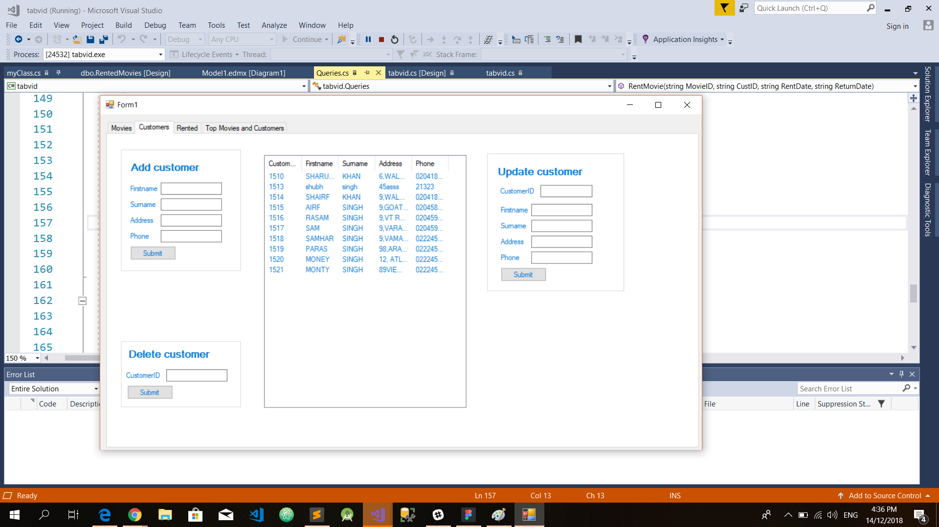

1. Adding Movies :

* *for adding a movie user had to put all input about movie to add and click submit*
* *After clicking submit the movie will be added and shown in the data grid view*

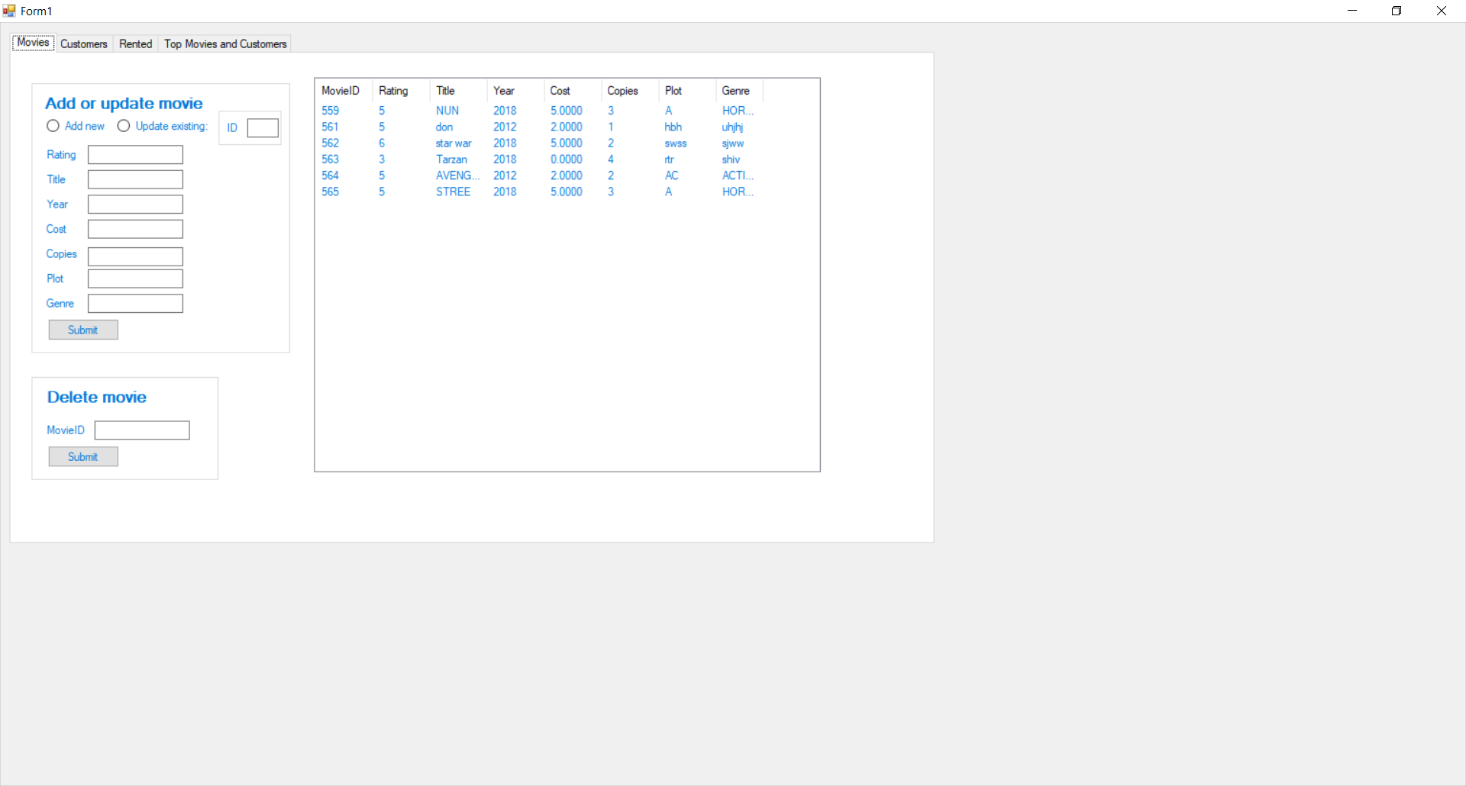

1. Update Movie/Customer/delete :

* *for adding updating user should write the Id and the section which he after clicking submit it will update*
* *for deleting user just have to write movie it and submit it will delete*



1. Delete Customer/ update customer :

* *for updating a customer there is separate panel where user had write the Id and the section which he after clicking submit*
* *for deleting customer just have to write movie it and submit it will delete*

**

1. Issue Movie / return movie :

* *for Issuing a movie to a customer will have to put movie id and customer id the date rented will automatically generate*
* *to return movie user just had to write the unique rmid and click submit the movie will be returned and get disappeared from the dataview grid*

